**Gaussian Kernel**

The Gaussian kernel is defined as:

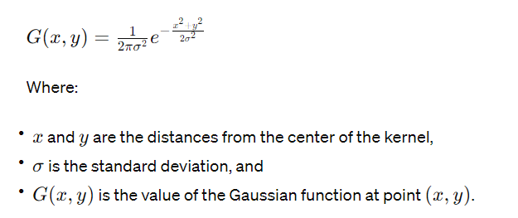

Table-1: Gaussian Kernel table

|  |  |
| --- | --- |
| **Kernel** | **Formatted Kernel** |
| [0.00291502 0.01306423 0.02153928 0.01306423 0.00291502]  [0.01306423 0.05854983 0.09653235 0.05854983 0.01306423]  [0.02153928 0.09653235 0.15915494 0.09653235 0.02153928]  [0.01306423 0.05854983 0.09653235 0.05854983 0.01306423]  [0.00291502 0.01306423 0.02153928 0.01306423 0.00291502] | [[ 1 4 7 4 1]  [ 4 20 33 20 4]  [ 7 33 54 33 7]  [ 4 20 33 20 4]  [ 1 4 7 4 1]] |

**Practical Experiment:**

**Grayscale image:**

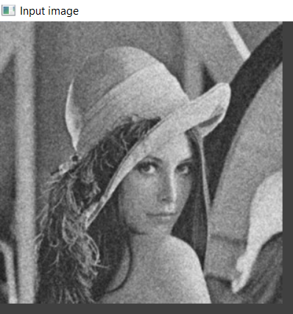 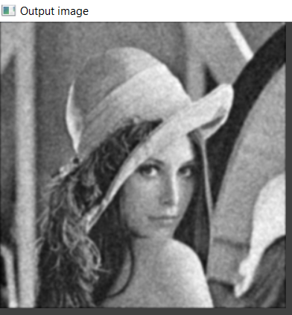

Fig-1: Input Image Fig-2: Output Image

**Mean Kernel**

Mathematically, the mean kernel is defined as a matrix of equal weights:

Table-2: Mean Kernel Table

|  |  |
| --- | --- |
| **Kernel** | **Formatted Kernel** |
| [[0.04 0.04 0.04 0.04 0.04]  [0.04 0.04 0.04 0.04 0.04]  [0.04 0.04 0.04 0.04 0.04]  [0.04 0.04 0.04 0.04 0.04]  [0.04 0.04 0.04 0.04 0.04]] | [[1. 1. 1. 1. 1.]  [1. 1. 1. 1. 1.]  [1. 1. 1. 1. 1.]  [1. 1. 1. 1. 1.]  [1. 1. 1. 1. 1.]] |

**Practical Experiment:**

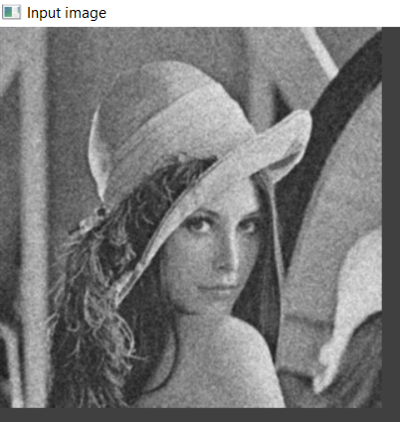 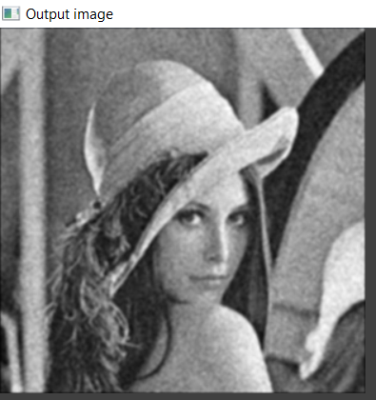

Fig-3: Input Image Fig-4: Output Image

**Laplacian kernel**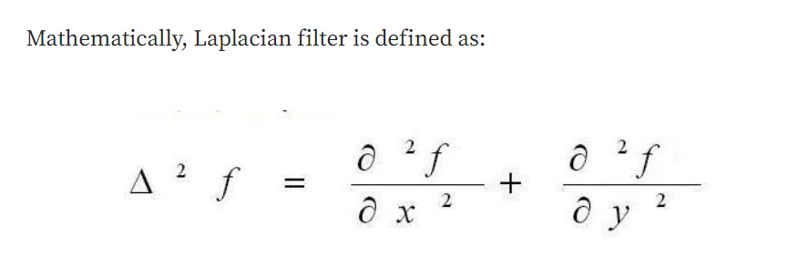

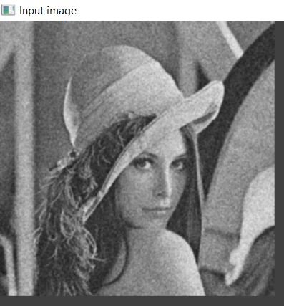 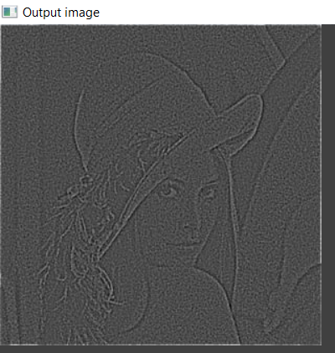

Fig-5: Input Image Fig-6: Output Image

**LOG Kernel:**

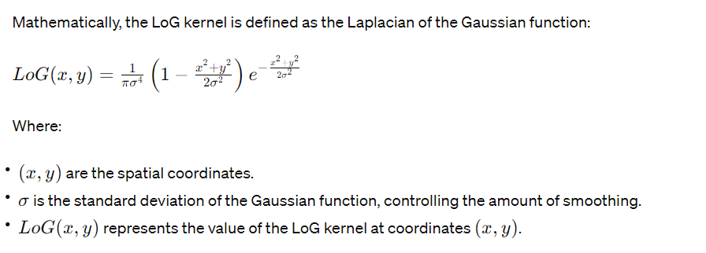

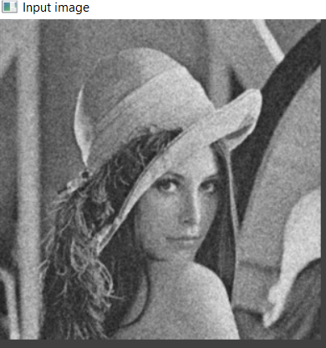 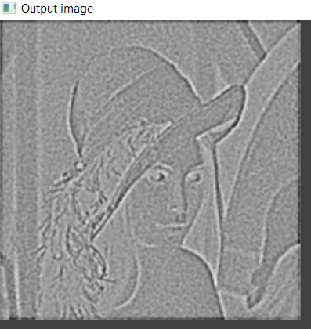

Fig-7: Input Image Fig-8: Output Image

**Sobel kernel**

|  |  |
| --- | --- |
| Horizontal Sobel Kernel | Vertical Sobel kernel |
| |-1 -2 -1 |  | 0 0 0 |  | 1 2 1 | | | -1 0 1 |  | -2 0 2 |  | -1 0 1 | |

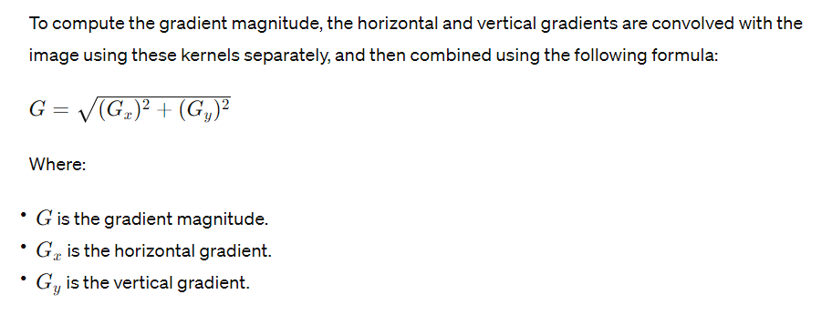

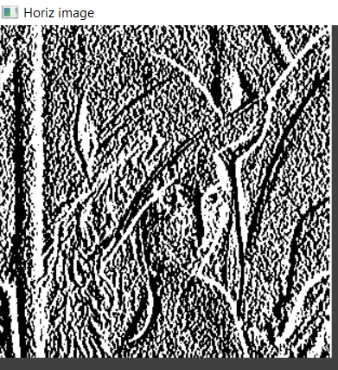 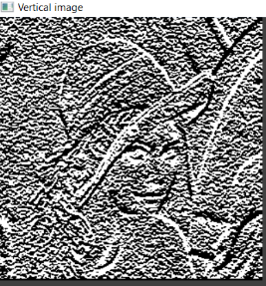 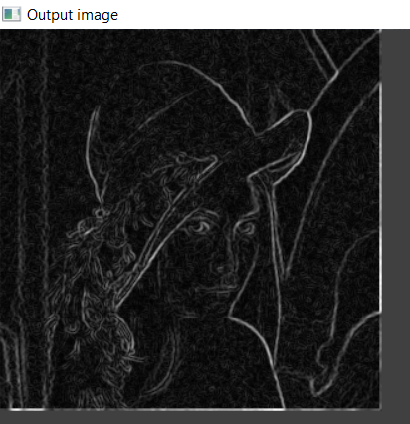

Fig-9: Horizontal Image Fig-10: Vertical Image Fig-11: Output Image

**Operation Type:** HSV & RGB Difference

1. Grayscale

Formatted gaussian filter

[[1 12 54 90 54 12 1]

[12 148 665 1096 665 148 12]

[54 665 2980 4914 2980 665 54]

[90 1096 4914 8103 4914 1096 90]

[54 665 2980 4914 2980 665 54]

[12 148 665 1096 665 148 12]

[ 1 12 54 90 54 12 1]]

Formatted kernel

[[1 12 54 90 54 12 1]

[12 148 665 1096 665 148 12]

[54 665 2980 4914 2980 665 54]

[90 1096 4914 8103 4914 1096 90]

[54 665 2980 4914 2980 665 54]

[12 148 665 1096 665 148 12]

[ 1 12 54 90 54 12 1]]

